**CNBU108 – APPLIED OPERATING SYSTEM**

**LAB 4**

**NAGIOS CORE – MONITOR SERVER**

**Dao Minh Chau-24560025**

**Objective**

* Student can install the Nagios Core with VMware
* Student can configure the Nagios Core to monitor the Linux/Windows Client

**Requirement**

* VMware

# 1. Download and install Nagios Core

* Student can download Nagios Core at: <https://www.nagios.org/downloads/>
* Depending on the OS, students follow the instruction of installation: <https://assets.nagios.com/downloads/nagioscore/docs/nagioscore/4/en/quickstart.html>

**First, update and install dependencies.**

sudo apt update && upgrade

sudo apt install -y autoconf gcc libc6 make wget unzip apache2 apache2-utsudo apt-get install -y openssl libssl-dev

**Downloading the Source**

cd /tmp  
wget https://github.com/NagiosEnterprises/nagioscore/archive/nagios-4.4.14.tar.gz  
tar xzf nagioscore.tar.gz

**Compile**

cd nagioscore-nagios-4.4.14  
sudo ./configure --with-httpd-conf=/etc/apache2/sites-enabled  
sudo make all

**Create User And Group**

This creates the nagios user and group. The www-data user is also added to the nagios group.

Sudo useradd nagios

Sudo groupadd nagcmd

Sudo usermod -a -G nagcmd nagios  
sudo usermod -a -G nagcmd www-data

**Install Binaries**

This step installs the binary files, CGIs, and HTML files.

sudo make install

**Install Service / Daemon**

This installs the service or daemon files and also configures them to start on boot.

sudo make install-daemoninit

**Install Command Mode**

This installs and configures the external command file.

sudo make install-commandmode

**Install Configuration Files**

This installs the *SAMPLE* configuration files. These are required as Nagios needs some configuration files to allow it to start.

sudo make install-config

**Install Apache Config Files**

This installs the Apache web server configuration files and configures Apache settings.

sudo make install-webconf

sudo a2enmod rewrite

sudo a2enmod cgi

**Then we need to create a nagios admin account**

Create nagiosadmin User Account and specify a password, in my case that is kali.

sudo htpasswd -c /usr/local/nagios/etc/htpasswd.users nagiosadmin

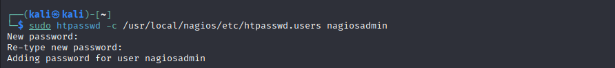

Then we need to install Nagios-plugins to use check_ncpa function to monitor NCPA agent.

wget https://github.com/nagios-plugins/nagios-plugins/archive/release-2.4.6.tar.gz

sudo tar xzf release-2.4.6.tar.gz

cd nagios-plugins-release-2.4.6

sudo ./tools/setup

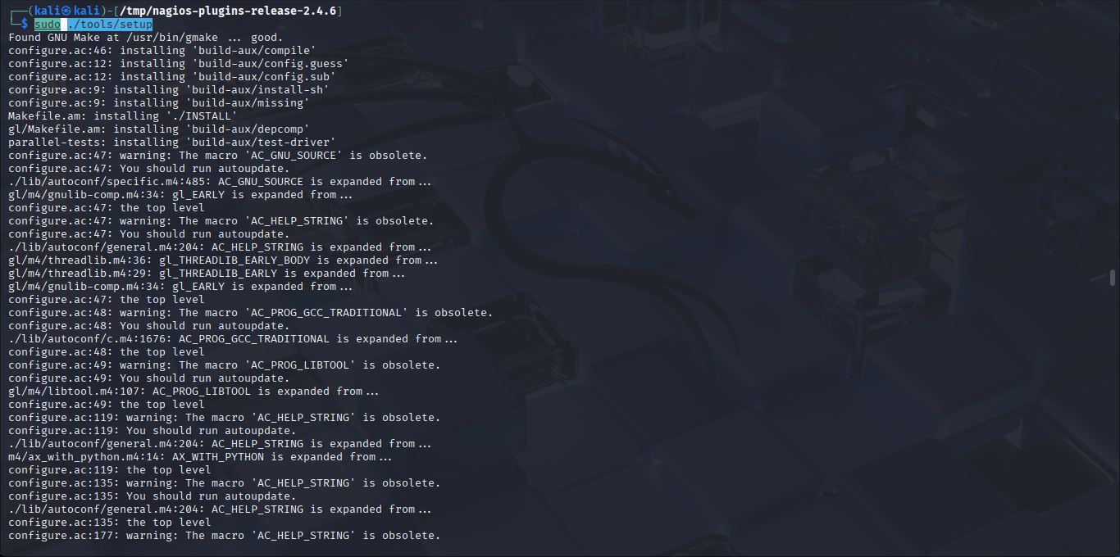

Finally start the nagios service and visit its website via my IP, 192.168.140.144/nagios and login as nagiosadmin

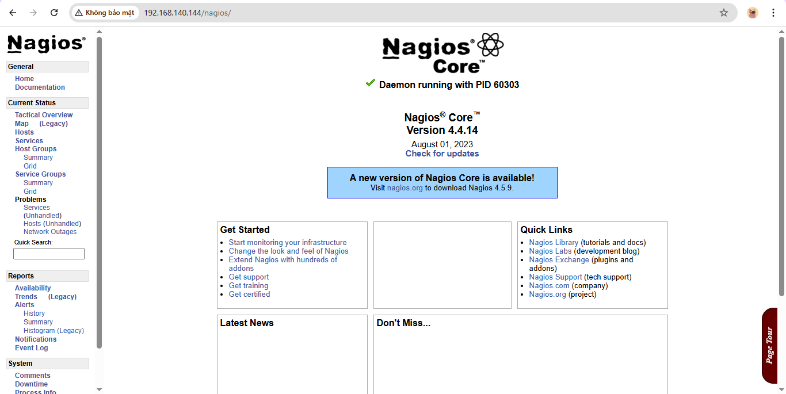

# 2. Install NCPA agent and configure the Nagios Core to monitor Windows client

* Students follow the instructions:

<https://assets.nagios.com/downloads/nagioscore/docs/nagioscore/4/en/monitoring-windows.html>

After installing NCPA, toggle to set Token to mytoken123 (or anything) and check for ipconfig to let the nagios listen to right device in later configuration.

For me the token is nagios, IP is 192.168.140.144 and use port 5693. Then go to service to check status of my device NCPA.

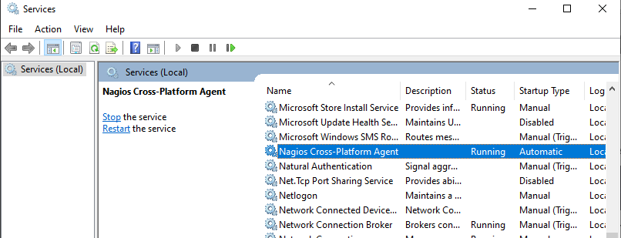

Then go to /usr/local/nagios/etc/objects/windows.cfg to define my window host and services to monitor CPU and Memory usage:

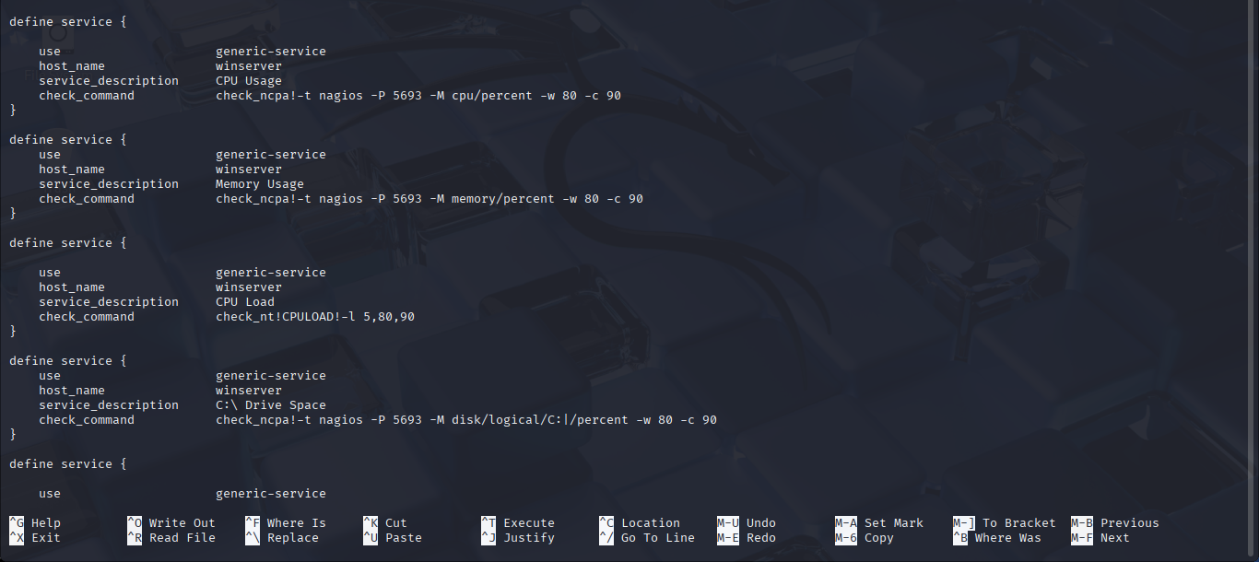

After finish configurating, use sudo /usr/local/nagios/bin/nagios -v /usr/local/nagios/etc/nagios.cfg to check errors if existed and then restart the nagios.

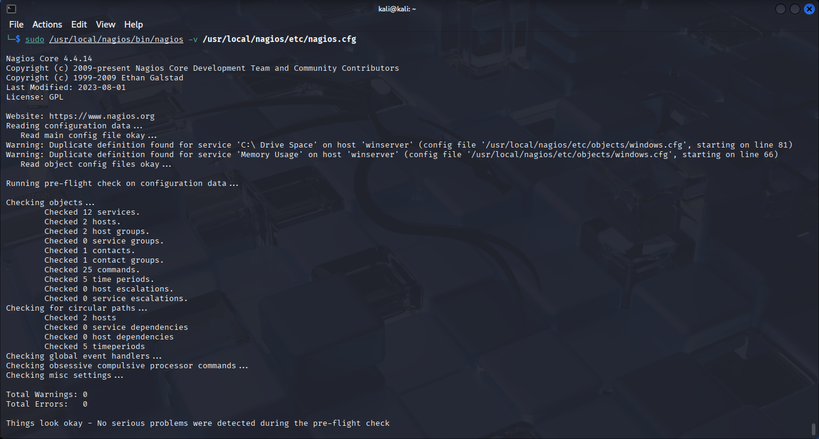

# 3. Inspect the monitoring view

* Students capture the monitor view and give short description on the dashboard.

The localhost is the one VM running nagios and the web, and the win client is my real device that run NCPA agent.

# 4. Create an event

* Base on the configuration information in steps 2. Make the CPU load or memory higher, so that Nagios can raise an alarm on the event of high CPU load or high memory.

I make a command to max out CPU usage in PowerShell and check in Nagios

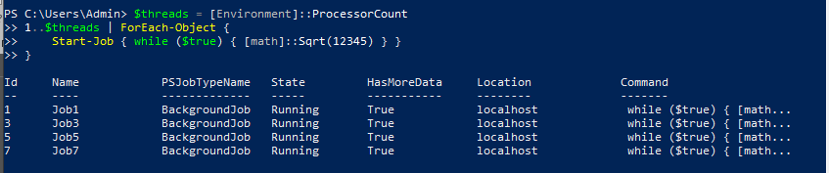

Then I go to Nagios and check.

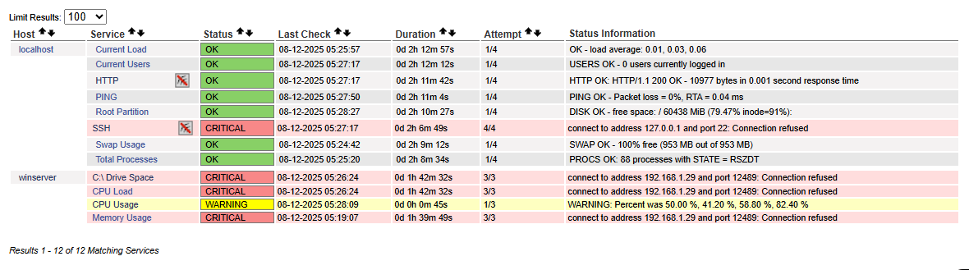

And after the traffic is released

